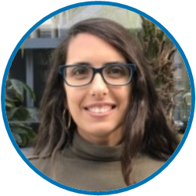
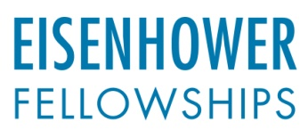
Latin America and Caribbean Program

Ursula Harman | Peru
District Councilwoman ∙ Municipal Council of San Bartolo

As a newly elected council member for the city of San Bartolo, a popular beach town in Lima, Peru, Ursula Harman facilitates community development by building partnerships with citizens and addresses concerns related to the area’s cultural heritage, natural resources and responsible tourism. As with any popular tourist destination, San Bartolo has struggled with efficient waste management, and local residents recently committed to allocating the 2019 municipal budget to a waste management program. While on fellowship, Harman will develop a waste management program based on inclusive innovation, aiming to find new solutions to this issue by bringing excluded groups into the decision-making process. She hopes to meet with U.S. and international agencies involved in the implementation of innovative waste management programs, which will create opportunities to share and exchange information that could result in collaborative changes for her community.

Professional Highlights
- District Councilwoman, Municipal Council of San Bartolo, 2019-present
- Lecturer and Researcher, Pontifical Catholic University of Peru, 2019 -present
- Lecturer, Department of General Studies - San Ignacio de Loyola University, 2019-present
- Coordinator of Academic Projects, Department of General Studies – San Ignacio de Loyola University, 2018
- Coordinator of the Social Area of the Support Group for the Rural Sector - Department of Engineering - Pontifical Catholic University of Peru, 2006-2012

Education
- PhD in Agriculture and Food Science, University of Queensland, Brisbane, 2017
- Masters in Innovation and Technology Management and Policy, Pontifical Catholic University of Peru, Lima, 2011
- BA in Sociology, Pontifical Catholic University of Peru, Lima, 2005

Fellowship Interests
- Developing a waste management program incorporating international best practices
- Incorporating inclusive governance practices into all facets of municipal government
- Developing research-based programs with universities that educate and build community capacity for innovation processes

For further information, contact Jake Schneider, Program Officer, at jschneider@efworld.org or +1.215.965.1974

